Exercise 8
1. How many unique salary packages does our company Bignet offer?
SELECT COUNT(DISTINCT salary) FROM employee_data;
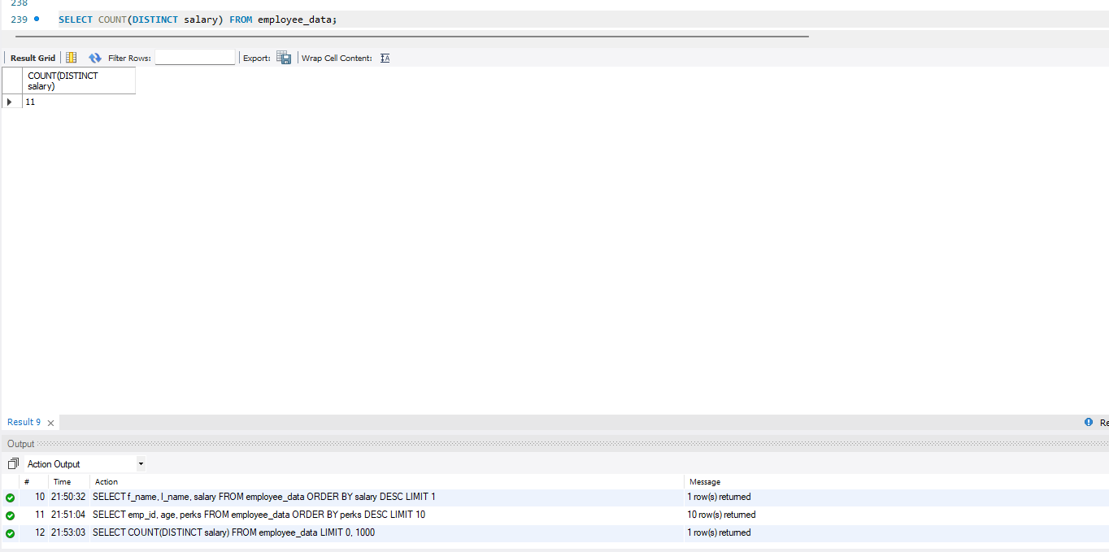
2. List the average age of employees working at Bignet.
SELECT AVG(age) FROM employee_data;
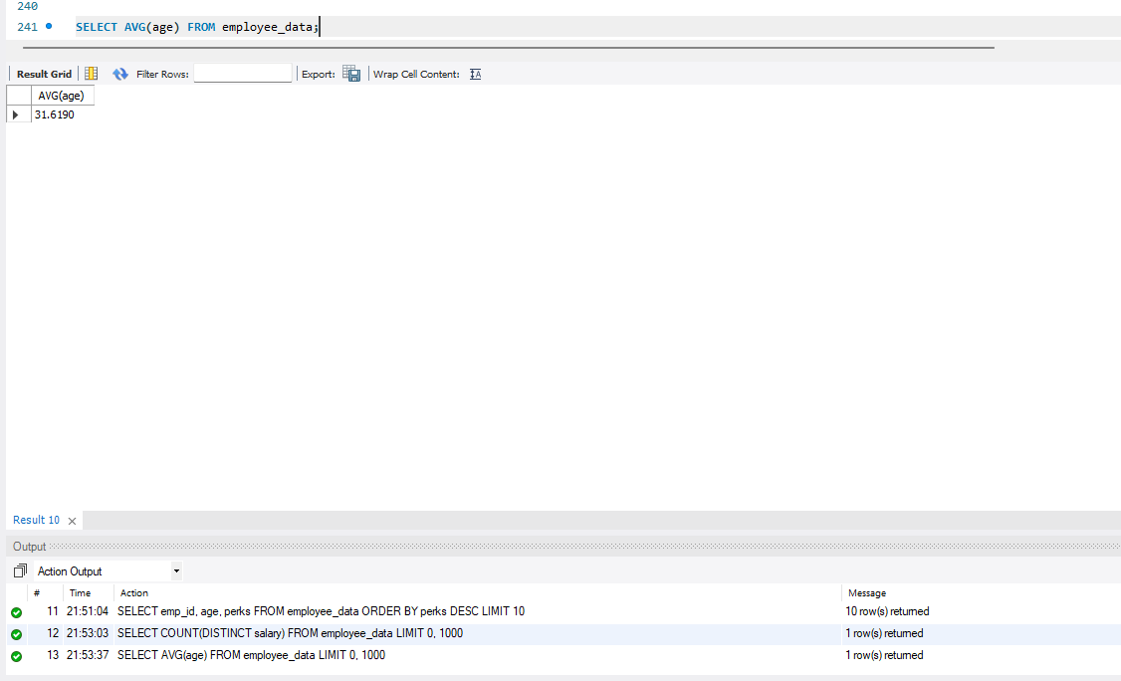

3. How many distinct first names do we have in our database?
SELECT COUNT(DISTINCT f_name) FROM employee_data;
